Title in Times New Roman 13-point, bold, centered (NOT in ALL CAPITAL letters), official language: English
{enter (12p)}
Presenting Author¹, Name Surname², …¹, Name Surname² (add Name and Surname for all authors, NO Abbreviations) (centered, 11p)
e-mail: email@address.it (centered, italics - 10p)
{enter (9p)}
¹ Dept, Institute, Address, ZIP/CAP-City, Country (centered, italics - 9p)
² Dept, Institute, Address, ZIP/CAP-City, Country (centered, italics - 9p)
{enter (12p)}
Please type the body of the abstract text here. References cited in the text must be included as [1], or [1] [2], for multiply cited for the same part of text (number placed before the punctuation mark and between square brackets). Tables cited as “Table 1” placed above the table and figures/schemes cited as “Figure 1”/”Scheme 1” placed below the figure/scheme (line spacing: 1.15 in 10-point Times New Roman, bold). Figures/schemes/table captions must follow the text rules (line spacing: 1.15 in 10-point Times New Roman, table-justified, figure/scheme-centered). Figures and schemes file extension png/jpg/tif with min 600dpi resolution are only allowed. Please look at the example below.
Please make a 1.0 cm indentation when starting a new line. Text should be justified on a page. References must be detailed at the bottom of the page as shown below. Please respect rigorously these formatting rules for references (line spacing: 1.15 in 9-point Times New Roman, justified).
THE ABSTRACT CANNOT EXCEED TWO PAGES (B5) OF TEXT, REFERENCES, TABLES AND FIGURES.
PLEASE DO NOT MODIFY FONT SIZE (10P), LINE SPACING (1.15) AND MARGINS (TOP: 2.0CM, DOWN: 1.5CM, LEFT: 2.0CM, RIGHT: 1.5CM)!!! These instructions are an example of what a properly prepared meeting abstract should look like. Authors are requested to strictly follow all of the requirements as here proposed.
PLEASE SEND THE ABSTRACT BEFORE MARCH 06. 2019 to nanoptoelectro2019@info.p.lodz.pl as a WORD document (ONLY “.doc” or “.docx” format allowed, WE WILL NOT ACCEPT “.pdf”). Please name your abstract: Surname_Name.doc(x).
{enter before Figure/Scheme/Table (10p)}
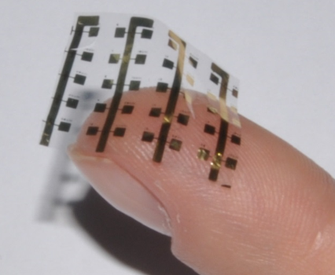
Figure 1: Caption here [2]. (no additional space between figure/scheme/table and description)
{enter before acknowledgements (10p)}
Acknowledgements, grant financing, etc. Times New Roman (9p), centered, italics
{enter before references (10p)}
[1] K. Binder, M. Müller, J. Baschnagel, Polymer models on the lattice, [in:] M. Kotelyanskii, D. N. Theodorou (eds.) Simulation methods for polymers, Marcel Dekker, New York-Basel 2004, 125-146.
[2] L. Monico, K. Janssens, E. Hendriks, F. Vanmeert, M. Cotte, G. Falkenberg, B. G. Brunetti, C. Milani, Angewandte Chemie International Edition, 2015, 54, 13293-13297.

